MINISTRY OF SCIENCE AND HIGHER EDUCATION
OF THE REPUBLIC OF KAZAKHSTAN
Karaganda University of KAZPOTREBSOYUZ
Faculty of Business, Law and Technology

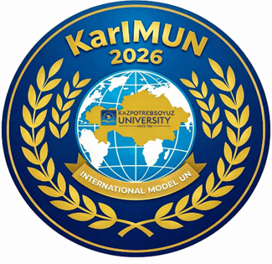
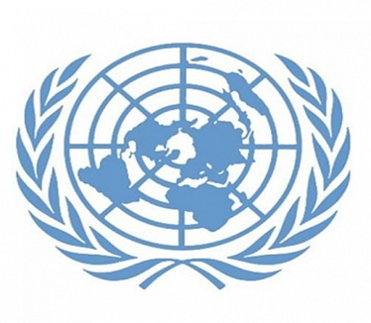

Karaganda International Model UN – 2026, organised by the Faculty of Business, Law and Technology at Karaganda University of Karaganda University of Kazpotrebsoyuz: ‘KarIMUN – 2026’

INFORMATION LETTER

28–30 April 2026
Karaganda
We invite you to take part in the 1st Karaganda International Model UN – 2026, organized by the Faculty of Business, Law and Technology at Karaganda University of Kazpotrebsoyuz, ‘KarIMUN – 2026’, which will take place on 28–30 April 2026!

“KarIMUN – 2026” is a large-scale and engaging role-playing game, as well as an academic conference for students, at which participants – delegates, observers, chairs and experts – act as official representatives of UN member states and international organizations who have come to the conference to discuss and resolve pressing international issues.
Participating delegates express the official position of the country they represent, take part in discussions, vote on UN resolutions, block resolutions from other countries if they have the right of veto, and actively communicate with one another through diplomatic meetings and correspondence.

https://forms.gle/BMY3U6Z9GH2se7WS9
https://t.me/KarIMUN2026
Agenda for the ‘KarIMUN – 2026’ Committees

UN General Assembly
Working language of the committee: Russian
Agenda: Preventing an arms race in the new geopolitical and political realities of the modern technological era.
The UN General Assembly is the Organization’s principal deliberative, policymaking and representative body. It is the largest and most extensive platform where delegates hone their skills in public speaking, negotiation and drafting resolutions on issues of global security, disarmament and development in accordance with international law.
The UN General Assembly deals with the full spectrum of international issues affecting all of humanity, and is also a unique forum for multilateral discussion of international security issues, in accordance with the UN Charter.

Committee Chair: Alina Rinatovna Khabibulina louisxvi@mail.ru
Committee Expert: Sergienko Elizaveta Igorevna yelizavetasergiyenko@gmail.com
Rehman Alexandra Dmitrievna aleksandrarehman@gmail.com
Committee Secretary: Vikhnevich Sofia

Economic and Social Council (ECOSOC)
Working language of the committee: Russian
Agenda: Combating poverty and raising living standards in developing countries.
ECOSOC is responsible for promoting improved living standards and full employment, as well as for seeking solutions to international problems in the economic and social spheres. This Committee acts as a link between the UN and civil society, including the academic community.
Within ECOSOC, delegates analyses issues relating to financial monitoring, sustainable development (SDGs) and the ethical regulation of new technologies (including artificial intelligence), which is directly relevant to our university’s current educational programmes.

Chair of the Committee: Gleb Andreevich Bakulin glebbakulin1@mail.ru
Committee Expert: Irina Evgenievna Shiryaeva shiraevairina169@gmail.com
Committee Secretary: Alina Baitakova

Special Committee on Political and Decolonization Issues
Working language of the committee: English
Agenda: "Questions of Western Sahara, the Falkland Islands (Malvinas) and Gibraltar: decolonization and self-determination in the framework of the Fourth International Decade for the Eradication of Colonialism"
(Consideration of the issues of decolonization and self-determination in relation to Western Sahara, the Falkland Islands (Malvinas) and Gibraltar in the context of the Fourth International Decade for the Eradication of Colonialism)
The Committee reviews the situation in Non-Self-Governing Territories and promotes the implementation of the Declaration on the Granting of Independence to Colonial Countries and Peoples. The Committee's activities are aimed at protecting the right of peoples to self-determination.
The Committee is the main mechanism for the implementation of one of the imperative principles of international law — the right of peoples to self-determination.
Within the framework of the UN Model, this allows the participating delegates to explore the fine line between the right to self-determination and the principle of territorial integrity of States.

Chairman of the Committee: Mamutov Farid mamutovfarid@gmail.com
Committee expert: Surkhayev Elmir el.surkhayev05@gmail.com
Committee Secretary: Daria Lukyanchuk

To take part in the 1st Karaganda International Model UN – 2026 organized by the Faculty of Business, Law and Technology at Karaganda University of Kazpotrebsoyuz (‘KarIMUN – 2026’):

STEP 1. Register for the committee of your choice by clicking on the link:
STEP 2. Within 2 days of the Expert’s report being published, send an abstract to the Expert via email for review. Reports will be published from 7 to 9 April.
STEP 3. Wait for the Expert’s response within 2 days of sending the abstract;
STEP 4. Join the chat for your chosen committee;
STEP 5. Prepare a report on behalf of a specific country, seeking assistance from the expert or chairperson if necessary;

Participation in both in-person and remote formats is available for those residing in other cities or countries. To do so, you must notify the Committee Presidium or the ‘KarIMUN – 2026’ Organizing Committee in advance.

